Guidelines for authors:

TITLE (COLOR 7/47/119)
Author’s Name

ABSTRACT

Abstract: Cambria, 9 pt, single spacing. Leave one blank line after the heading. The abstract should be 150–250 words in length. Lorem Ipsum is simply dummy text of the printing and typesetting industry. Lorem Ipsum has been the industry's standard dummy text ever since the 1500s, when an unknown printer took a galley of type and scrambled it to make a type specimen book. It has survived not only five centuries, but also the leap into electronic typesetting, remaining essentially unchanged. It was popularised in the 1960s with the release of Letraset sheets containing Lorem Ipsum passages, and more recently with desktop publishing software like Aldus PageMaker including versions of Lorem Ipsum.

KEYWORDS: Provide three to five keywords.

FIRST LEVEL HEADING

Body text: Cambria, 10 pt, line spacing 1.08. Leave one blank line between paragraphs. Main (first-level) headings: 11 pt, bold. Leave two blank lines before the heading and one blank line after it. Heading color: RGB (0, 174, 239).

Manuscript length: The paper should not exceed 15 pages. Lorem Ipsum is simply dummy text of the printing and typesetting industry. Lorem Ipsum has been the industry's standard dummy text ever since the 1500s, when an unknown printer took a galley of type and scrambled it to make a type specimen book. It has survived not only five centuries, but also the leap into electronic typesetting, remaining essentially unchanged. It was popularised in the 1960s with the release of Letraset sheets containing Lorem Ipsum passages, and more recently with desktop publishing software like Aldus PageMaker including versions of Lorem Ipsum.

FIRST LEVEL HEADING

Second level heading

Second-level headings: 11 pt. Color: RGB (0, 174, 239). Leave one blank line before and one blank line after the heading.

Lorem Ipsum is simply dummy text of the printing and typesetting industry. Lorem Ipsum has been the industry's standard dummy text ever since the 1500s, when an unknown printer took a galley of type and scrambled it to make a type specimen book. It has survived not only five centuries, but also the leap into electronic typesetting, remaining essentially unchanged. It was popularised in the 1960s with the release of Letraset sheets containing Lorem Ipsum passages, and more recently with desktop publishing software like Aldus PageMaker including versions of Lorem Ipsum.

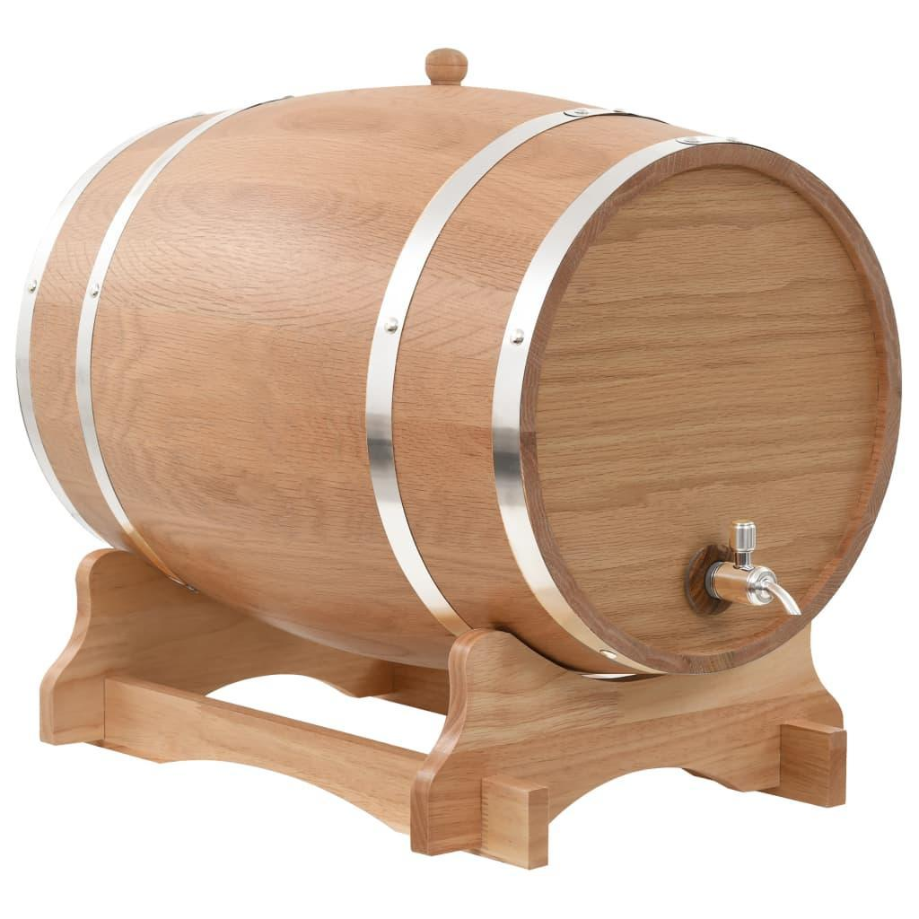
Figure 1. Figure 1 title
Source:creation of the author or reference formatted like reference from reference list

Titles and sources should be placed below figures, charts, and tables.
Formatting: Cambria, 9 pt, color RGB (0, 174, 239).

Use the Harvard citation style in the text (author’s surname and year, page number if available).

Examples:
(Kastelan Mrak et al. 2023, p. 14)
(Kelin and Srok, 2015, p. 232)
(Vretenar, 2025)

For web sources, include the title and date of access (do not include the hyperlink).
For databases, official decisions, regulations, strategies, and similar documents, include the title, year, and page number if available.
For laws, include only the Official Gazette number and year (e.g., NN 118/18).

REFERENCES
- Font: Cambria, 9 pt. Paragraph spacing: 6 pt before, 0 pt after.
- Use APA style for the reference list. Where available, always include DOI numbers. If the author is known, always include the author.
- The literature for Croatian and English versions of the chapter should generally be the same, differing only in conjunctions when necessary.
- Grady, J. S., Her, M., Moreno, G., Perez, C., & Yelinek, J. (2019). Emotions in storybooks: A comparison of storybooks that represent ethnic and racial groups in the United States. Psychology of Popular Media Culture, 8(3), 207–217. https://doi.org/10.1037/ppm0000185 (journal)
- Dillard, J. P. (2020). Currents in the study of persuasion. In M. B. Oliver, A. A. Raney, & J. Bryant (Eds.), Media effects: Advances in theory and research (4th ed., pp. 115–129). Routledge. (chapter in edited book)
- Jackson, L. M. (2019). The psychology of prejudice: From attitudes to social action (2nd ed.). American Psychological Association. https://doi.org/10.1037/0000168-000 (book)
- Hygum, E., & Pedersen, P. M. (Eds.). (2010). Early childhood education: Values and practices in Denmark. Hans Reitzels Forlag. https://earlychildhoodeducation.digi.hansreitzel.dk/ (edited book)
- Business in the village of Loznati with only 37 inhabitants: The united brothers develop sheep farming and build a modern cheese factory. Link: https://www.novilist.hr/regija/biznis-u-selu-loznati-od-samo-37-zitelja-udruzenibratici-razvijaju-ovcarstvo-i-grade-modernu-siranu/. (Accessed: June 20, 2024). (internet and other)

